For Setting logging in terraform, enable logging by using below commands:

For Windows CMD : SET TF_LOG=DEBUG

For Windows Powershell : $env:TF_LOG="TRACE" , Get-ChildItem Env:, $env:TF_LOG_PATH**=**"terraform.txt"

To remove the Powershell Env Variable: $env:TF_LOG=’ ’ $env:TF_LOG_PATH=’ ‘

For Linux: export TF_LOG=DEBUG

<https://www.digitalocean.com/community/tutorials/how-to-troubleshoot-terraform>

<https://www.terraform.io/docs/cli/config/environment-variables.html>

<https://www.phillipsj.net/posts/how-to-configure-logging-for-terraform/>

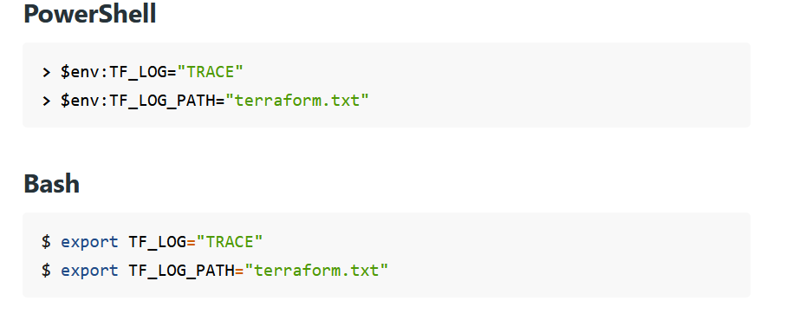

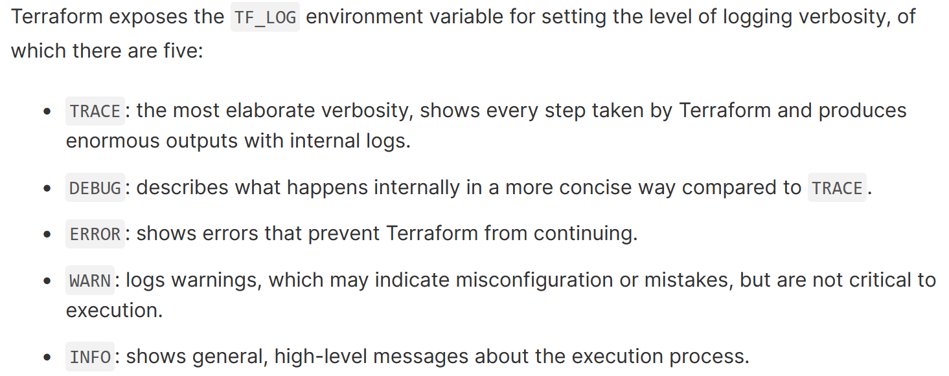

To test TF Logging, deploy AWS NLB with delete protection enabled using modules or normal tf files. Try to destroy the configuration which will stuck at “Deleting Gateway”.

Stop the execution and enable the TF logging based on you operating system and run the execution again which can show the error happening because of the NLB.

Change the code enable_deletion_protection = false to true and perform following command:

terraform apply -target module.testenv_nlb.aws_lb.test

THis will disable the delete protection and apply terraform destroy again to delete everything.